**18. Kubernetes Deployment - Pause and Resume Deployments**

--- Reference - https://github.com/stacksimplify/kubernetes-fundamentals/tree/master/04-Deployments-with-kubectl/04-04-Pause-and-Resume-Deployment

**Introduction**

--- **Why do we need Pausing & Resuming Deployments?**

If we want to make multiple changes to our Deployment, we can pause the deployment make all changes and resume it.

We are going to update our Application Version from V3 to V4 as part of learning "Pause and Resume Deployments"

**Pausing & Resuming Deployments**

--- Check current State of Deployment & Application

**# Check the Rollout History of a Deployment**

--- **kubectl rollout history deployment/my-first-deployment**

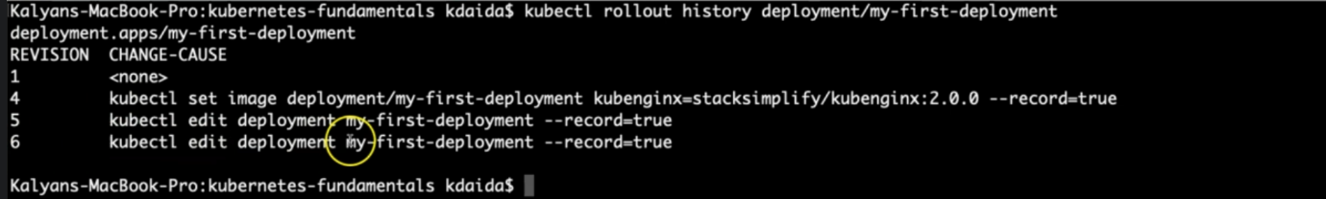

--- note – we are at revision 6.

--- **Observation**: Make a note of last version number

**# Get list of ReplicaSets**

--- **kubectl get rs**

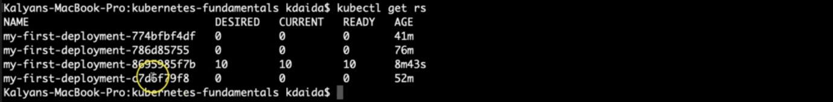

--- **note** – currently we have 4 replicaset. If you do another deployment the it will create a new replicaset.

--- **Observation**: Make a note of number of replicaSets present.

**# Access the Application**

--- **http://<worker-node-ip>:<Node-Port>**

--- **Observation**: Make a note of application version

**Pause Deployment and Two Changes**

**# Pause the Deployment**

--- **kubectl rollout pause deployment/<Deployment-Name>**

--- **kubectl rollout pause deployment/my-first-deployment** – once our deployment is paused then we can make any number of changes we want.

**# Update Deployment - Application Version from V3 to V4**

--- **kubectl set image deployment/my-first-deployment kubenginx=stacksimplify/kubenginx:4.0.0 --record=true**

**# Check the Rollout History of a Deployment**

--- **kubectl rollout history deployment/my-first-deployment**

--- **Observation**: No new rollout should start, we should see same number of versions as we check earlier with last version number matches which we have noted earlier.

**# Get list of ReplicaSets**

--- **kubectl get rs**

--- **Observation:** No new replicaSet created. We should have same number of replicaSets as earlier when we took note.

**# Make one more change: set limits to our container**

--- **kubectl set resources deployment/my-first-deployment -c=kubenginx --limits=cpu=20m,memory=30Mi**

**Resume Deployment**

**# Resume the Deployment**

--- **kubectl rollout resume deployment/my-first-deployment**

**# Check the Rollout History of a Deployment**

--- **kubectl rollout history deployment/my-first-deployment**

--- **Observation**: You should see a new version got created

**# Get list of ReplicaSets**

--- **kubectl get rs**

--- **Observation**: You should see new ReplicaSet.

**Access Application**

**# Access the Application**

--- **http://<node1-public-ip>:<Node-Port>**

--- **Observation**: You should see Application V4 version

**Clean-Up**

**# Delete Deployment**

--- **kubectl delete deployment my-first-deployment**

**# Delete Service**

--- **kubectl delete svc my-first-deployment-service**

**# Get all Objects from Kubernetes default namespace**

--- **kubectl get all**